|  |  |  |  |
| --- | --- | --- | --- |
| Name: | ___________________________________________________ | Date: *___________* | |
|  | **Mathematics Specialist Unit 2**  **Investigation 4 - 2018**  **Topic – Calculating orbits**  **Take home component** |  | |
| **Date out:** | *Week - 9 Date __________* | |  |
| **Assessment weighting** | *5% of the year.* | |
| **Task conditions**  The students complete the preparation activity prior to the validation. The validation task is for 30 min and may have take home component as notes. Students will be expected to submit the take home component with the validation task.  **Course-related information**  The concepts and skills included in this investigation relate to the following dot points within the WA Mathematics Specialist syllabus:   * 2.1.1  Determine all solutions of *f(a(x−b))=c* where *f* is one of sine, cosine or tangent * 2.1.2  Graph functions with rules of the form *y=f(a(x−b))*+c where *f* is one of sine, cosine, or  tangent | | | |

**Background information**

As mathematicians in the US space program, you and your team have been assigned the task of determining the first orbit of the Space Shuttle on the next mission. Your project is to determine the orbit of the shuttle and any other information that might affect the remainder of the orbits during the remainder of this flight. (Will all orbits cross over the same initial points? Explain why or why not. )

Some points to remember are the shuttle may not cross land on the initial lift-off and the shuttle will launch from Kennedy Space Center in Florida.

Watch the youtube clip for some ideas of how orbits work

<https://www.youtube.com/watch?v=J8qB3NIyOXw>

Materials that may be used to complete this project include:

* Globe
* Blue Tack
* String
* Copy of a world map
* Colored pencils or pens
* Grid paper
* Ruler

To begin your project:

* Use the string to measure the circumference of a “great circle” by measuring the circumference of the globe at the equator.
* Beginning at Kennedy Space Center, use your string to mark a great circle, which represents your proposed orbit. Your orbit should alternate north and south of the equator. Hold the string in place around the globe with the poster putty.  Consider how you would define your orbit path.
* Plot the coordinates of the orbit as ordered pairs (longitude, latitude) on a flat map of the globe.
* Plot the coordinates of your orbit on graph paper. Use the intersection of the equator and the prime meridian as your origin.

Find a sinusoidal (sine) equation to fit your data. Include your coordinates for the orbit and show how you determined the equation of the orbit.

Explore what influences the orbits and the impact on the sin equations. Are cosine equations are a better fit? Why or why not?

You may use a graphing calculator to check your work.

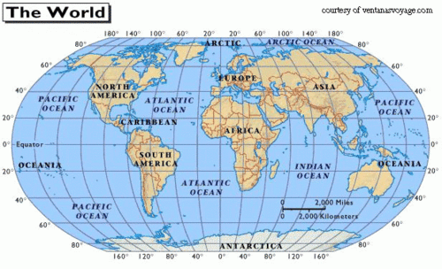

*Remember, you will be assessed for your use of the mathematical investigation process. That is:*

* *Interpretation of the task and key information required*
* *Identification of the mathematics which could help to complete the task*
* *Analysis of the information and data from a variety of sources*
* *Application of the mathematical knowledge and strategies from the course to calculate a solution*
* *Verification of the reasonableness of the solution*
* *Communication of the solution and findings in a clear manner.*

|  |  |  |  |
| --- | --- | --- | --- |
| Name: | ___________________________________________________ | Date: *___________* | |
|  | **Mathematics Specialist Unit 2**  **Investigation 4 - 2018**  **Topic – Calculating orbits**  **Validation** |  | |
| **Date out:** | *Week - 9 Date __________* | |  |
| **Assessment weighting** | *5% of the year.* | |
| **Task conditions**  The students will have to complete the preparation activity and then will be allocated 30 minutes for the in-class validation, where the skills used will be assessed. Students will not be expected to remember the rules used in the Take home component part but should be able to apply them.  **Course-related information**  The concepts and skills included in this investigation relate to the following dot points within the WA Mathematics Specialist syllabus:   * 2.1.1  Determine all solutions of *f(a(x−b))=c* where *f* is one of sine, cosine or tangent * 2.1.2  Graph functions with rules of the form *y=f(a(x−b))*+c where *f* is one of sine, cosine, or  tangent | | | |

**Background**

A satellite is to be launched from WA (just north of Carnarvon – 24°S 114°E)

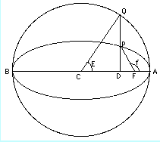It is the plan to place in an orbit given the following information

* Angle of inclination of 55° (represented by E on the diagram
* It travels fast enough to complete a single orbit in 24 hours (it returns to be above Carnarvon 24 hours after it left)
* It orbits symmetrically around the equator

**Task -** Find a sinusoidal (sine) equation to fit the above data.

Include your coordinates for the orbit and show how you determined the equation of the orbit. Use the intersection of the equator and the prime meridian as your origin.

